|  |  |
| --- | --- |
| **WRITTEN ASSESSMENT** | **Uncontrolled when printed**  **16/12/2014**  **FM02_21a** |

|  |  |  |  |  |  |  |  |  |  |
| --- | --- | --- | --- | --- | --- | --- | --- | --- | --- |
| **Student Name:** | | | ANGELO PALAZZOLO | | | **Student Number:** | | | 3150704699 |
| **Unit Code/s & Name/s:** | | | **ICADB412A & ICAWEB503A - Build a Database & Build Web Programs** | | | | | | |
| **Assessment Type:** | | | **Exam/Test  Assignment  Other** | | | | | | |
| **Assessment Description:** | | | **P2 –Build a Database & Build a Web Program** | | | | | | |
| **Assessment Due Date:** | | |  | | **Assessment Received Date:** | | |  | |
| **Student Declaration:** I declare that this assessment is my own work. Any ideas and comments made by other people have been acknowledged as references. I understand that if this statement is found to be false, it will be regarded as misconduct and will be subject to disciplinary action as outlined in the TAFE Queensland Student Rules. I understand that emailing or submitting this assessment electronically confirms my assent to this declaration in lieu of written signature. | | | | | | | | | |
| **Student Signature:** | |  | | | | **Date: / /** | | | |
| **Assessor Feedback:**  **Student provided with feedback** | | | | | | | | | |
| **Attempt 1 Satisfactory  Not Satisfactory  Date:      /     /** | | | | | | | | | |
| **Attempt 2 Satisfactory  Not Satisfactory  Date:      /     /** | | | | | | | | | |
| **Assessor Name:** |  | | | **Assessor Signature:** | | |  | | |
| **Note to assessor: Please record any adjustment below that has occurred to this assessment e.g. written assessment given orally.** | | | | | | | | | |
|  | | | | | | | | | |
| **Disclaimer:** TAFE Queensland North (TQN) is collecting the information on this form for assessment purposes. Only authorised Departmental officers have access to this information. Your personal information will not be disclosed to any other third party without your consent, unless authorised or required by law, in accordance with the Information Privacy Act 2009. | | | | | | | | | |

**This section must be completed by the student when the student either posts or hands a completed assessment/assignment to customer service centres. a receipt is only issued for face to face assessments when requested by the student.**

✀ **RECEIPT**

|  |  |  |
| --- | --- | --- |
| STUDENT TO COMPLETE |  | OFFICE USE ONLY |
| Unit of competency code/s:__________________ |  |  |
| Assessment item/No: ______________________ |  | Date received: / / |
| Student’s name: __________________________ |  |  |

|  |  |
| --- | --- |
| **Instructions to Student:** | **Time allowed:** This assessment is to be completed over the semester.  **Materials and equipment to be supplied by the Student:**   * Access to a PC, MySQL server, EXAMPP or WAMP Server with PHPAdmin, * **General Instructions:** * You will need access to the folder ‘Cluster 2 Assessment’, which is in your Student Shared Drive and available through your Google Drive. * You have 4 tasks to complete. * You will need to answer **all** questions correctly * Keep a copy of all assessments as you will be required, to submit them on GITHUB to your teacher.   NOTE: If you are not successful on your first attempt, you will be given comments and a further two weeks to rectify the changes.  You will need to re-submit your corrections for remarking. If you are unsuccessful on your second attempt, you will be required to re-enrol in this unit. ALL SUBMITTED WORK MUST BE YOUR OWNPlagiarism Is An Offence To avoid plagiarism, you must give credit whenever you use:   * Another person’s idea, opinion, or theory * Any facts, statistics, graphs, drawings—any pieces of information— information that is not common knowledge * Quotations of another person’s actual spoken or written * Paraphrasing of another person’s spoken or written words |
| **Instructions to Assessor:** | Please see Instructions to Student above. |
| **Assessment Context and Description: (if required)** | In order to gain competency in P2 **ICADB412A & ICAWEB503A Build a Database & Build a Web Program,** successful completion is required of the following assessments items:   * Written Assessment |
| **Note to Student:** | An Assessment Matrix is available from your teacher upon request. The matrix shows how the knowledge and skills that you are being asked to demonstrate align to the Elements, Performance Criteria, Critical Aspects, Required Skills and Required Knowledge components of each Unit of Competency. |

This assessment is the second stage of your Database Cluster Assessment. In this assessment you are required to build a website as a GUI for the database you developed and designed in Practical Assessment 1 for Cluster 2.

You should create a new folder for this project called **databases_webapp_yourname**' and save all project files in this folder. You should create sub folders as necessary.

Task 1

***For this task you are required to research HTTP and answer a few questions about it:***

* + ***Describe HTTP***

HTTP is the abbreviated form for HyperText Transfer Protocol, and is a set of standards that allow users of the World Wide Web to exchange information found on web pages. When accessing any web page entering http:// in front of the address tells the browser to communicate over HTTP. While, now, no longer necessary, it is used to differentiate between other protocols such as FTP (File Transfer Priotocol)

Information is exchanged between clients and servers in the form of Hypertext documents, from which HTTP gets its name. Hypertext is structured text that uses logical links or hyperlinks between nodes containing text. Hypertext documents can be manipulated using the Hypertext Markup Language (HTML). By using HTTP and HTML, users can request different pieces of web content such as text, images, video, and application data from web and application servers that host the content.

HTTP follows a request-response process in which the user makes a request and the server issues a response that includes not only the requested content, but also relevant status information about the request. This self-contained design accommodates for the fact that a request or response might pass through many intermediate routers and proxy servers. It also allows intermediary servers to perform value-added functions such as load balancing, caching, encryption, and compression. HTTP resources such as web servers are identified across the Internet using unique identifiers known as Uniform Resource Locaters (URLs).

**System States and HTTP**

In the fields of computer programming and communication protocols, the term ‘state’ refers to all the information to which the program has access. More specifically, it refers to the management of the information the system requires at any given point of time. A computer (program) must store information/data in variables, which represent storage locations in the computer's memory. The contents of these memory locations, at any given point in the program's execution, is called the program's state. As in humans, whom possess short-term and long-term memory (which they draw from, to perform tasks), computer systems possess the two states of ‘stateless’ and ‘stateful’.

With the stateless state (equivalent to short-term memory in humans), the data entered by the user is held by the computer or program, for as long as it is needed for the current task or until the connection to the computer or program is broken. After this point the information entered is removed from the system.

With the stateful state (equivalent to long-term memory in humans), the data entered by the user is held by the computer or program indefinitely, or until the computer or program is terminated.

HTTP is considered to be a stateless system. When a web site is accessed, the HTML code is loaded and remains in the system for as long as the content remain on the screen. When the user moves to another site, or to another page, the existing content/code is removed. If the user wishes to return to a previous page or site, the content/code must be re-loaded into the web browser. The advent of cache (special, resident computer memory) gives the impression of statefulness, but the content of the page is still being re-loaded from the local /cached source rather than the original source.

In order to have stateful communication, a site must incorporate a special program or code that the server can call, that can record and retrieve state information. An example of this is PHP (or “*PHP: Hypertext Preprocessor”)* ; PHP is a server-side scripting language designed for web development but also used as a general-purpose programming language that can evaluate form data sent from a browser, talk to and retrieve data from a database, and even send and receive cookies (little packets of data that your browser uses to remember things, like if you're logged in to website. The incorporation of ‘global variables’ within the php code, allows the system to retain the data assigned to those variable in memory, even if the user moves to other pages.

* + ***Describe limitations of HTTP when developing web applications.***
    - In HTTP is that every asset requires its own request, so if you have 5 images, 1 CSS file, and 2 JavaScript files included in your webpage then 10 HTTP requests must be made (i.e. 1 for the page itself, 1 to check for a favicon, 5 for the images, 1 for the CSS file, 2 for the JavaScript file)
    - HTTP is a text based protocol, with all its communication pretty much readable, with no decoding, translation or decryption required. Despite being one of the most commonly used mode of transport for personal information, HTTP operates almost entirely in clear text, thus making it extremely vulnerable to attack.
    - Each transaction is essentially separate from others. While the user may perceive the transaction as an ongoing communication, there is no preservation of data (state) thus all the data must be re-loaded or requested of the user again
  + ***Identify the advantages of HTTP when developing web applications.***
    - One of the main advantages I consider is that we can easily identify each request and each one is independent.
    - HTTP simplifies the server design because there is no need to dynamically allocate storage to deal with conversations in progress. If a client dies in mid-transaction, no part of the system needs to be responsible for cleaning up the present state of the server.
    - Connection is closed quickly - if a user goes to your website and leaves the connection on all night, your server doesn't have to maintain the connection
    - Web services can treat each method request independently.
    - Web services need not to maintain client's previous interactions. It simplifies application design. This means that a client is only consuming resources on the web server during the processing of a request-response cycle.
    - Fast, flexible and pragmatic, PHP powers everything from your blog to the most popular websites in the world.

Task 2 – Create your website/web application.

For this task you are required to use the clickable wireframe (developed in practical assessment 1 for this cluster) to develop your responsive web application utilising HTML, CSS, Javascript and PHP. It is recommended that you utilise Bootstrap or another responsive framework to develop your web application.

Ensure that your website includes:

* Appropriate reports to display required information in your database to various users.
* Ensure your web application manages sessions and enables a user to log in/log out and view information in your database.
* Sufficient data in the database so that appropriate reports can be generated. This is to include as a minimum:
* 10 unique vehicles (2 on special),
* 5 unique customers,
* 3 salespersons,
* 5 sale transactions,
* 8 manufacturers and
* 5 categories of vehicles.

Task 3 – Write a brief on you database/web application

***For this task you are required to write a brief documenting your web application and its implementation. This brief you need to:***

* Outline the output reports generated by your website, including screen shots of the reports and the SQL code used to fetch the data.
* The website accesses the database called “database_wca_angelo” within which are contained the tables:
* car
* category
* customers
* manufacturer_id
* sale
* staff

The staff have been allocated a security level, as either “Admin” (for Administration staff) an d “Sales” (for salesperson). On logging into the staff only section of the website, via the “Employee Login” button, the staff member is directed to the appropriate user interface (UI) based on their security level.

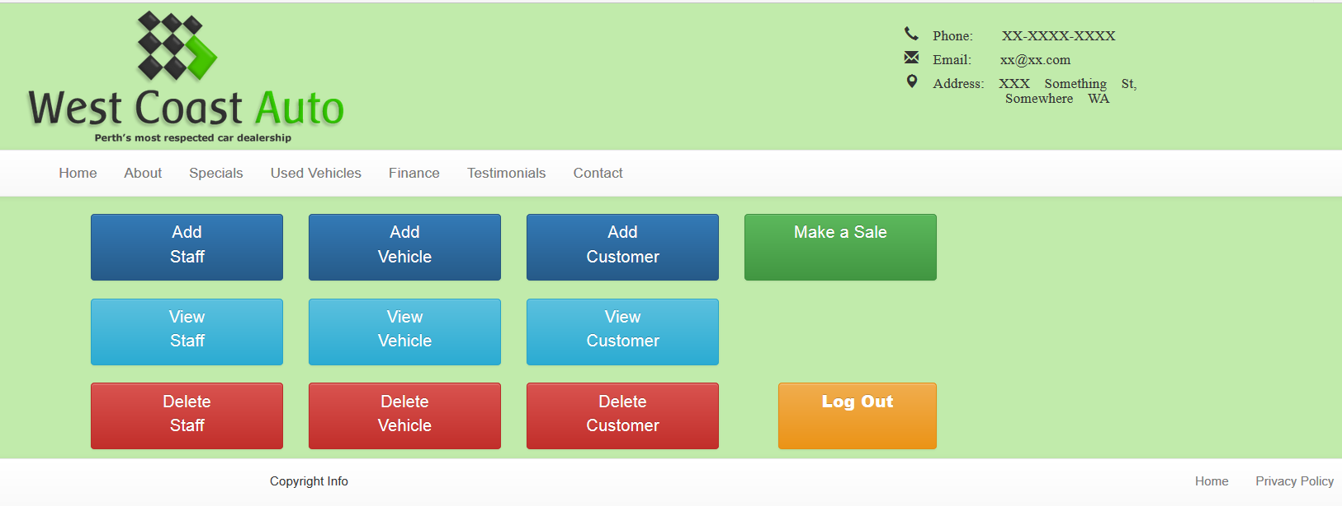

Figure 1: The “Admin” UI, displaying all the fuctions appropriate to their security level

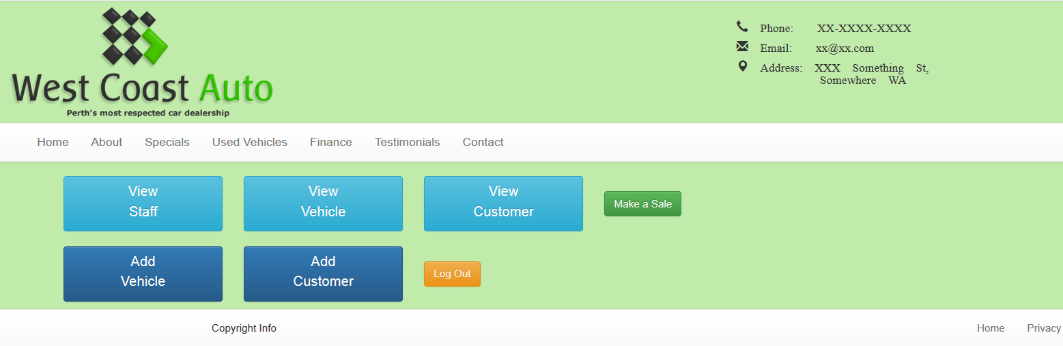

Figure 2: The "Sales" UI, displaying all the fuctions appropriate to their security level

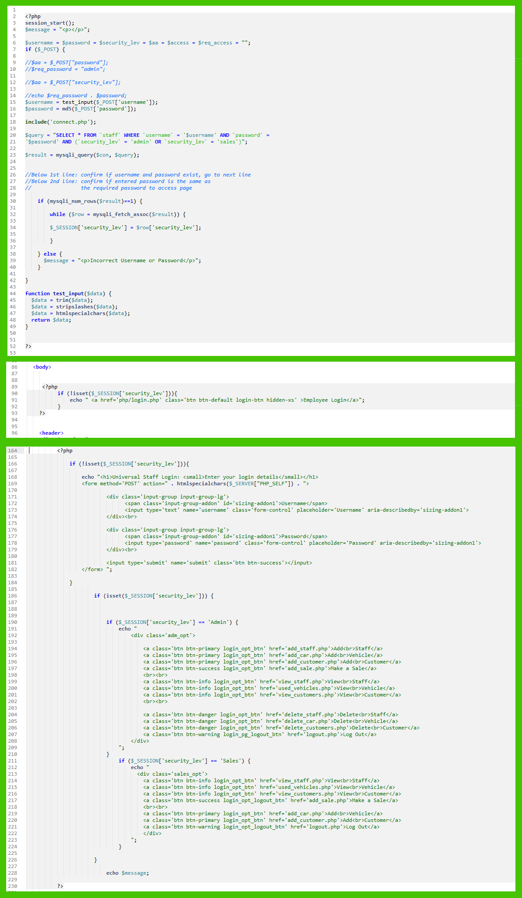

… for ‘Admin’ level

… or for ‘Sales’ level

If that which the user entered exist in database, the script then takes the security level of that user and creates a global variable, that will be held in memory and can be used I within other pages.

Searches database for username, password and security level .

Security: The username blank-spaces, slashes and no-alpha-numeric characters removed to ensure malicious code is not being entered.

Identifies what security level the user has, and then displays the appropriate UI

If security level HAS been set (ie user HAS logged-in) then the login script is called & form appears and user must login

If security level has NOT been set (ie user has NOT logged-in) then the login script is called & form appears and user must login

If security level has NOT been set (ie user has NOT logged-in) then the login button is present on screen.

Figure 3: PHP script for the login page

The following image document the reports (or outputs) generated by the php code after the staff member performs the relevant tasks. In addition, to verify that the task has in fact appropriately modified the database content, an image of the database table has been included as has an image pf the appropriate php code.

**Administration “Admin” User Interface (UI)**

* 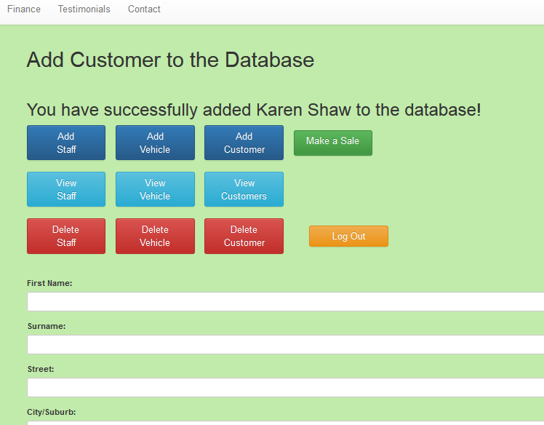

Figure 4: Feedback indicating the success addition of a customer.

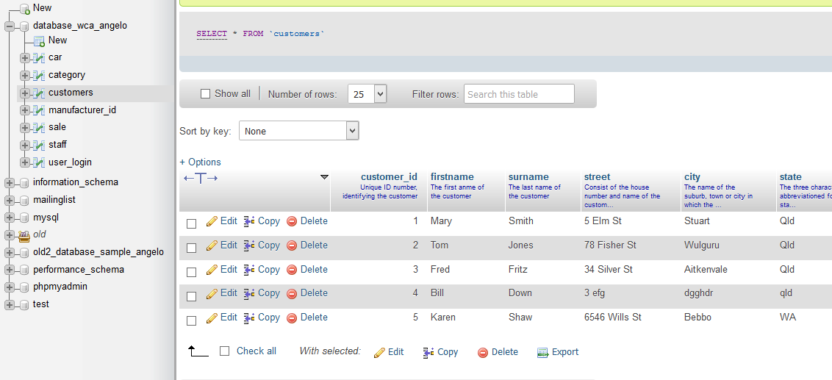

Figure 5: Success evidenced in the database table.

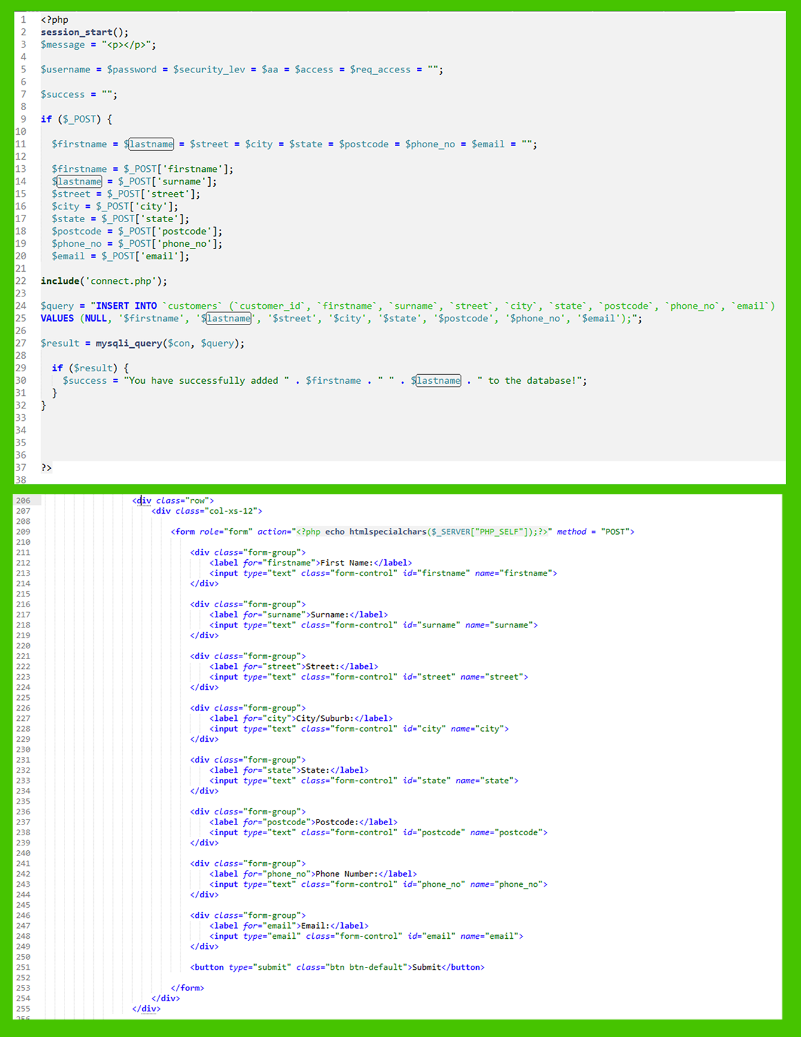

Figure 6: PHP script for the creation of a new customer field in the database table.

* 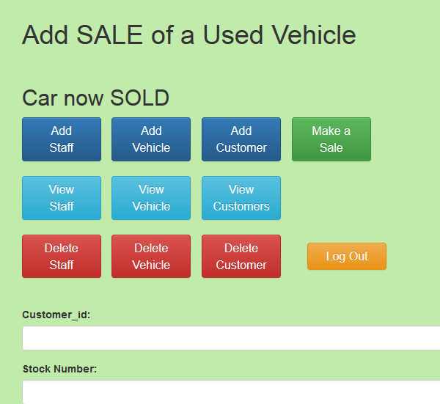

Figure 7: Feedback indicating the success sale of a vehicle field.

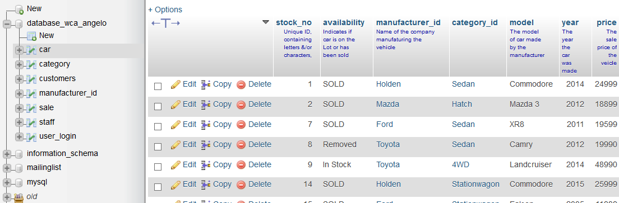

Figure 8: The success sale of a vehicle field, evidenced in the database table.

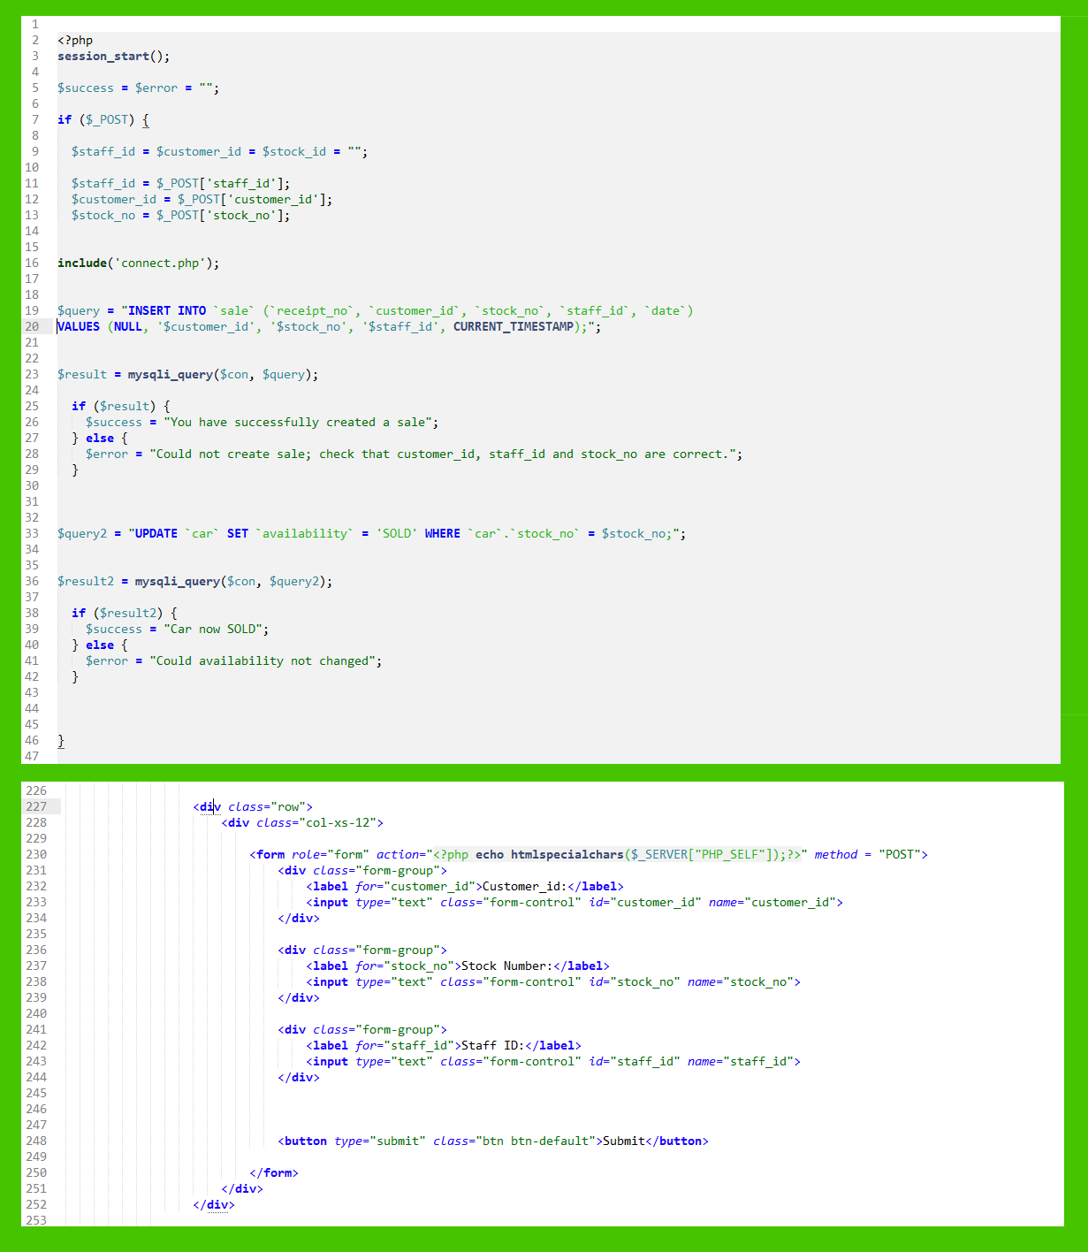

Figure 9: PHP script for the recording the sale of a vehicle, in the database table.

* 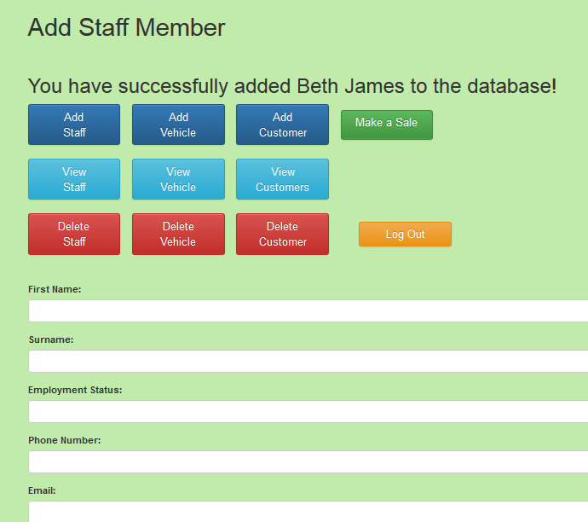

Figure 10: Feedback indicating the success addition of a new staff member.

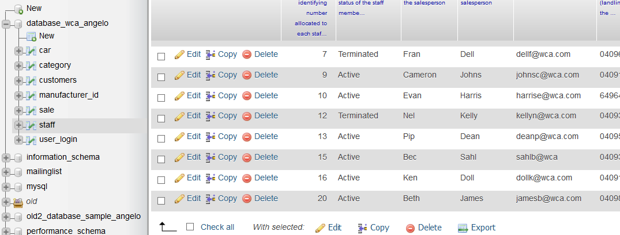

Figure 11: The success addition of a new staff member, evidenced in the database table.

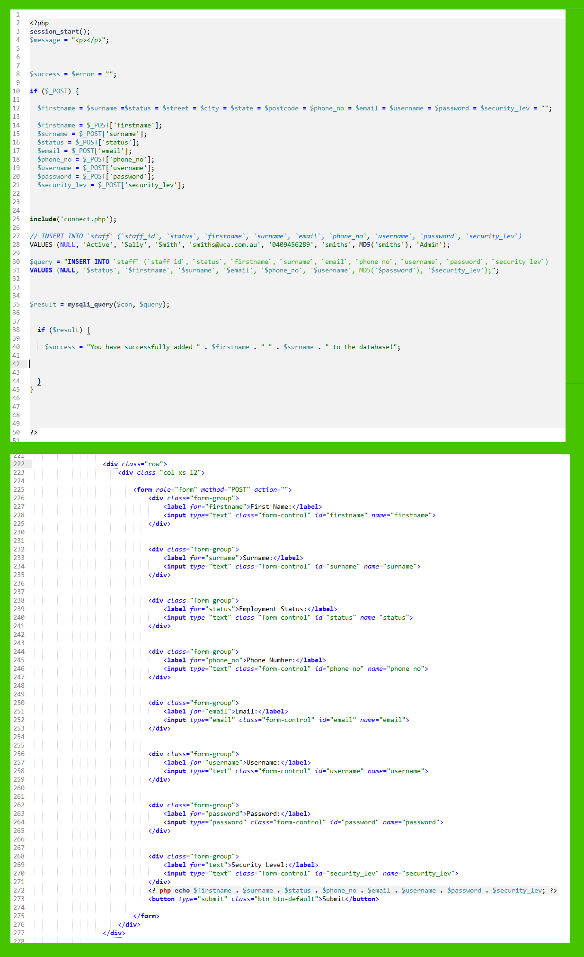

Figure 12: PHP script for the creation of a new staff member field in the database table.

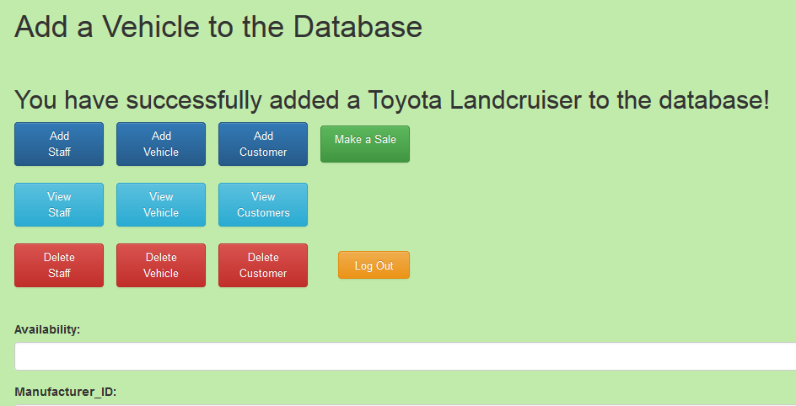

Figure 13: Feedback indicating the success addition of a vehicle.

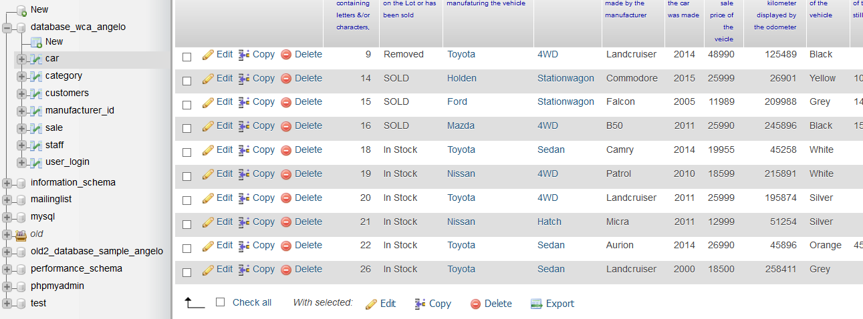

Figure 14: The success addition of a new vehicle, evidenced in the database table.

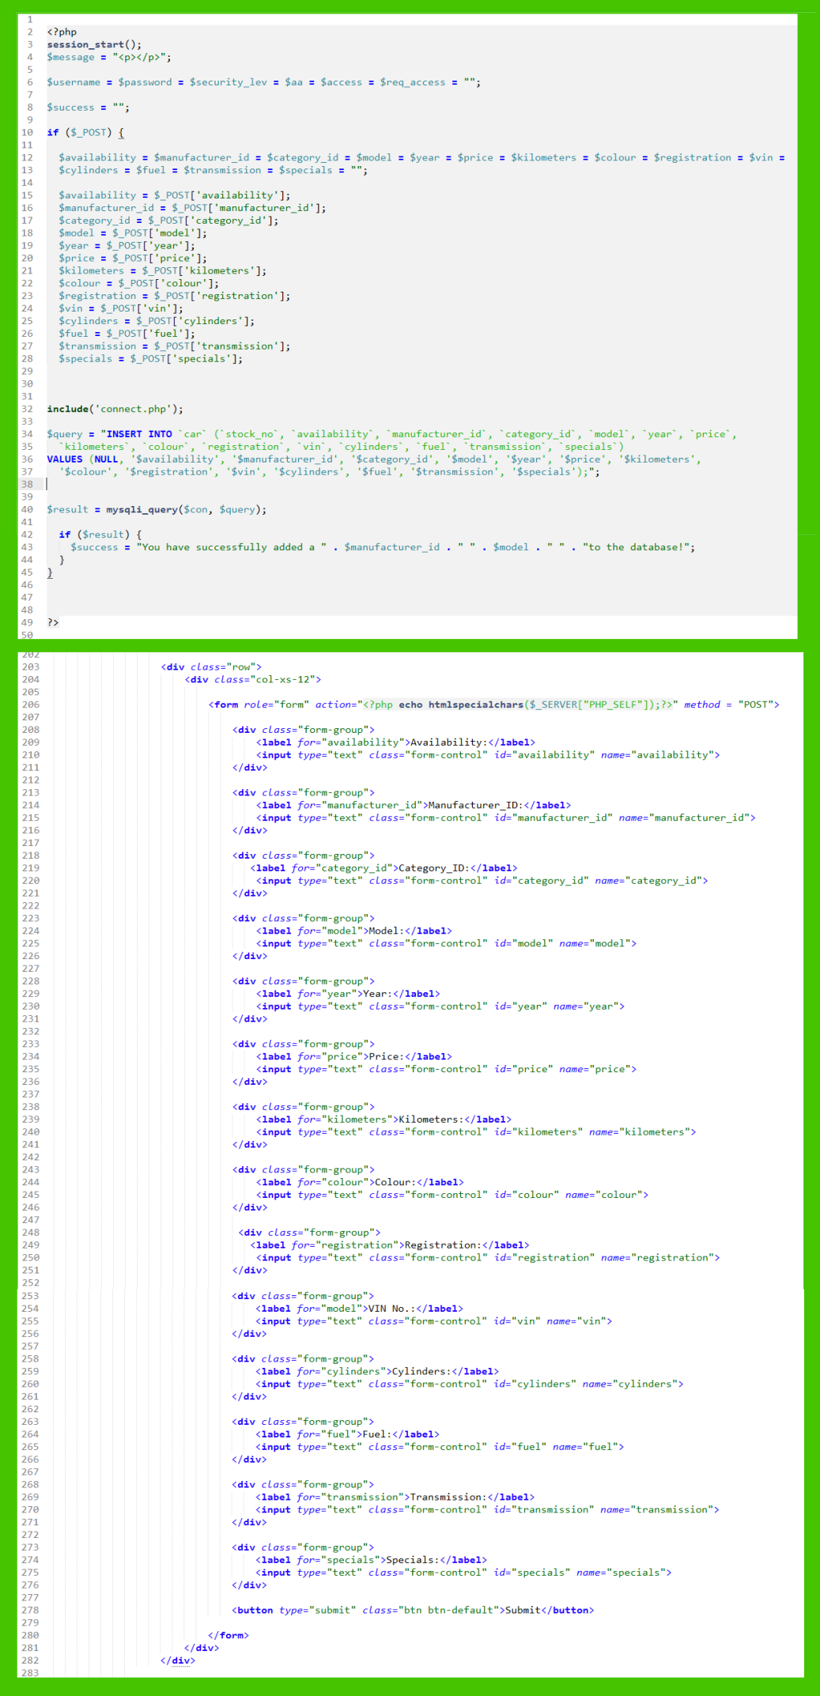

Figure 15: PHP script for the addition of a new motor vehicle field in the database table.

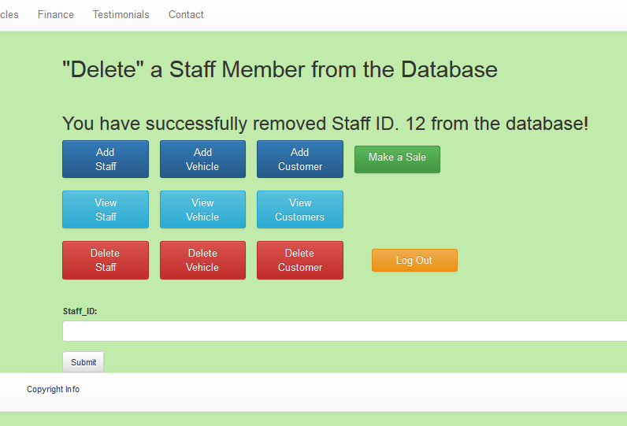

Figure 16: Feedback indicating the success “deletion” (or re-classification) of a staff member from the database.

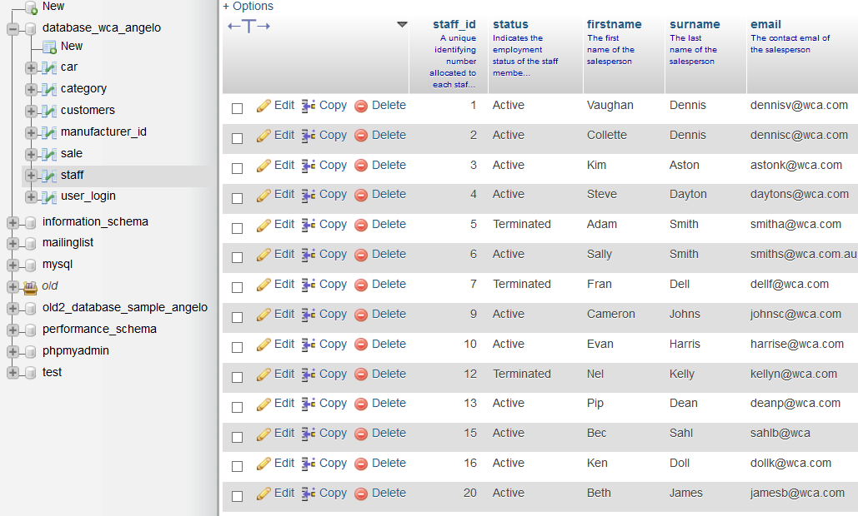

Figure 17: The success “deletion” (or re-classification) of a staff member, evidenced in the database table ..

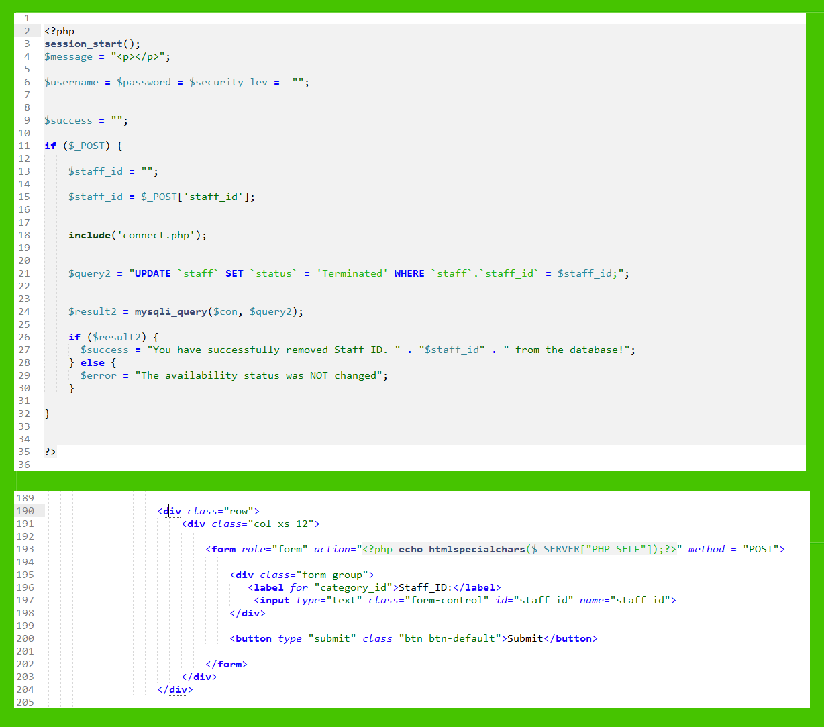

Figure 18: PHP script for the “deletion” (re-classification) of the staff member field in the database table.

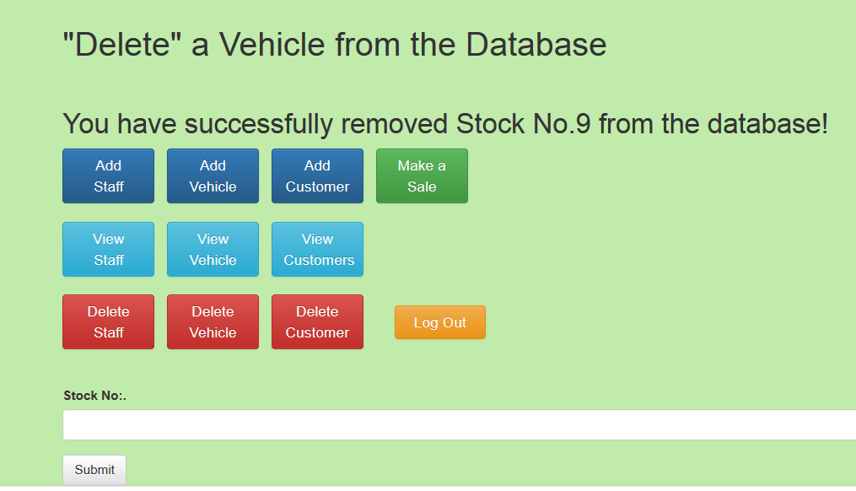

Figure 19: Feedback indicating the success “deletion” (or re-classification) of a vehicle field.

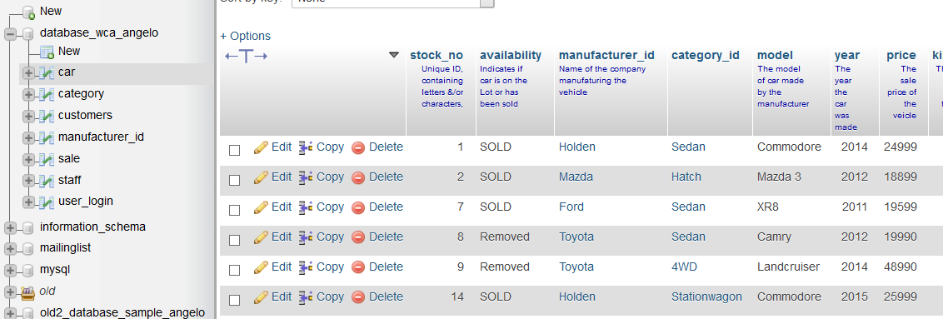

Figure 20: The successful “deletion” (or re-classification) of a vehicle field, evidenced in the database table .

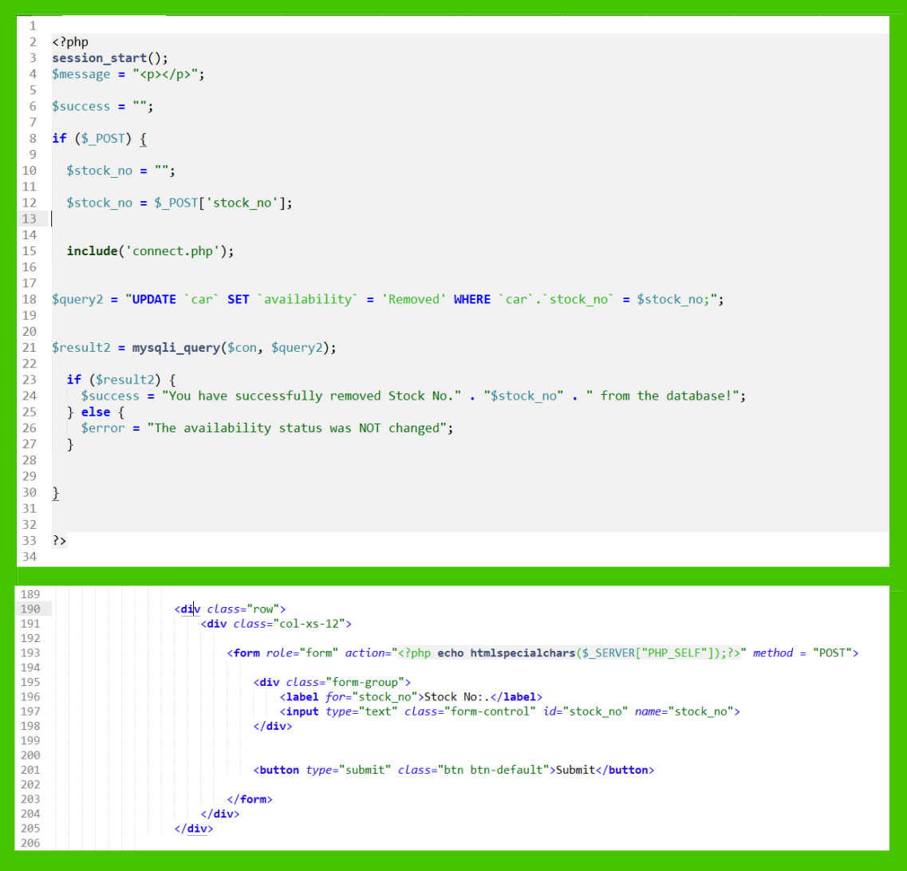

Figure 21: PHP script for the “deletion” (or re-classification) of a vehicle field in the database table.

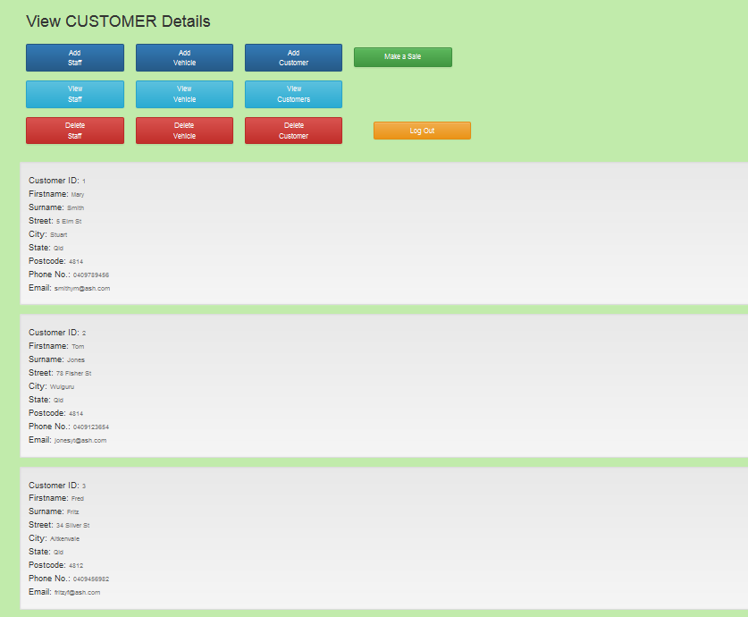

Figure 22: The successful request to view of all the customers of WCA, from the database table.

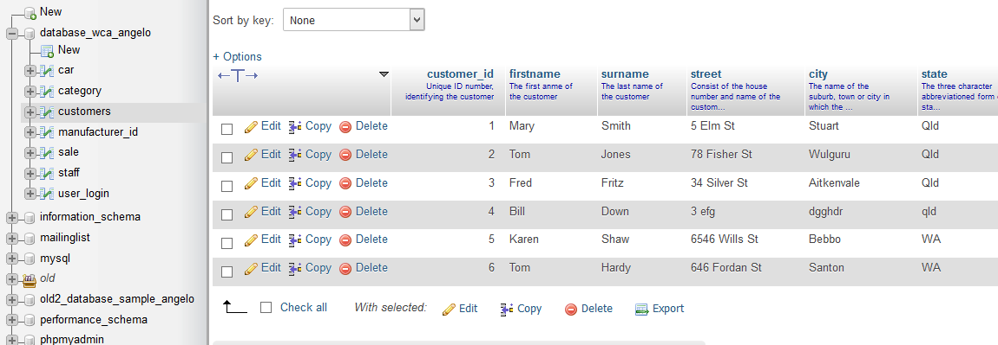

Figure 23: The current customer data stored in the “customer” table in the database table.

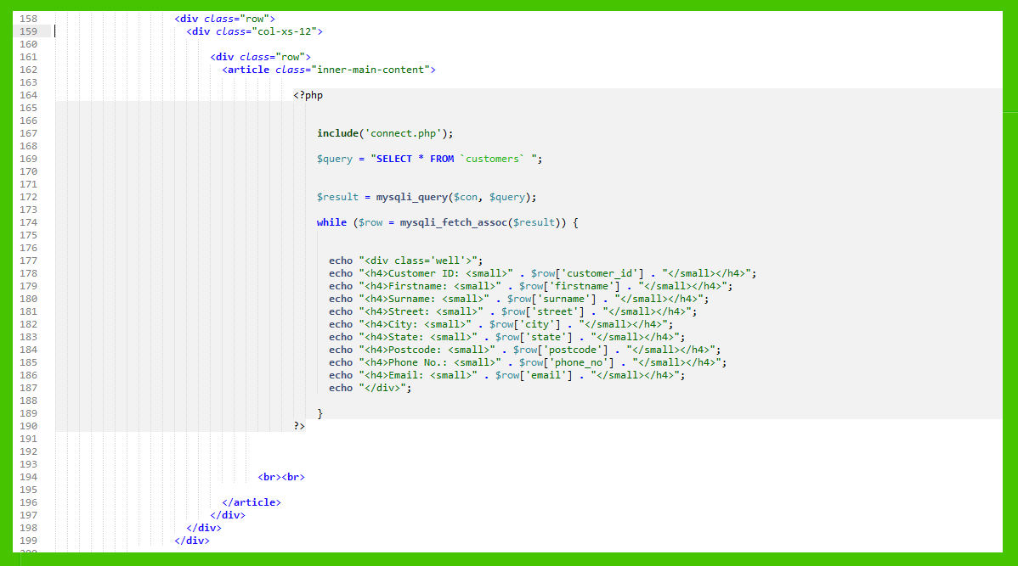

Figure 24: PHP script view all the customer details, in the database table.



Figure 25: A view of all current (or “Active”) staff members at WCA, from the database table.

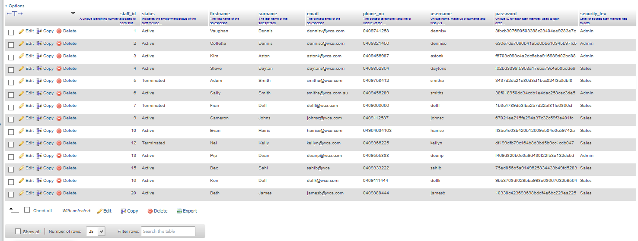

Figure 26: The current staff data stored in the “staff” table in the database table.

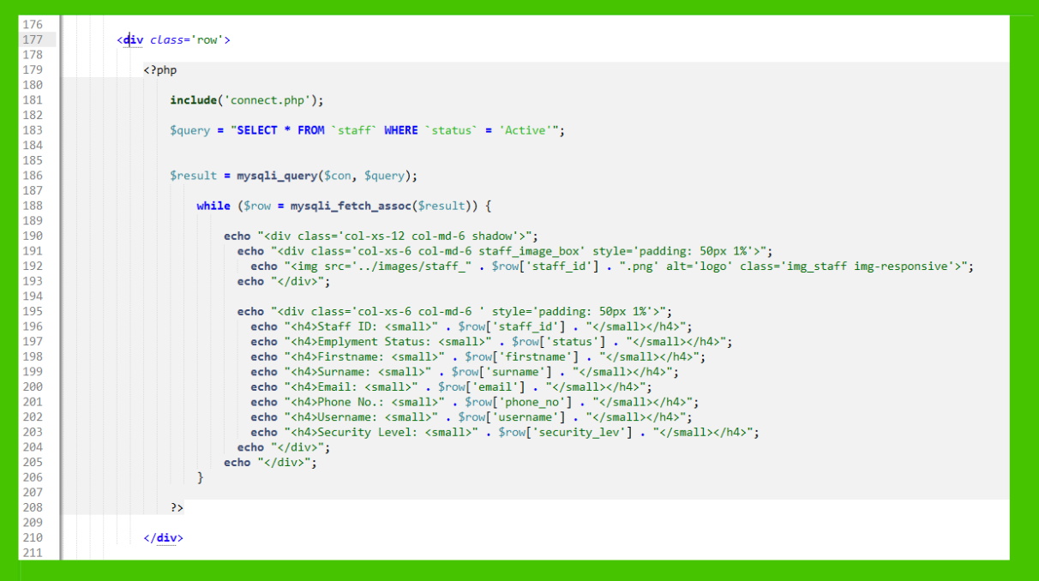

Figure 27: PHP script to view all and only the current/”active” staff members in the database table.

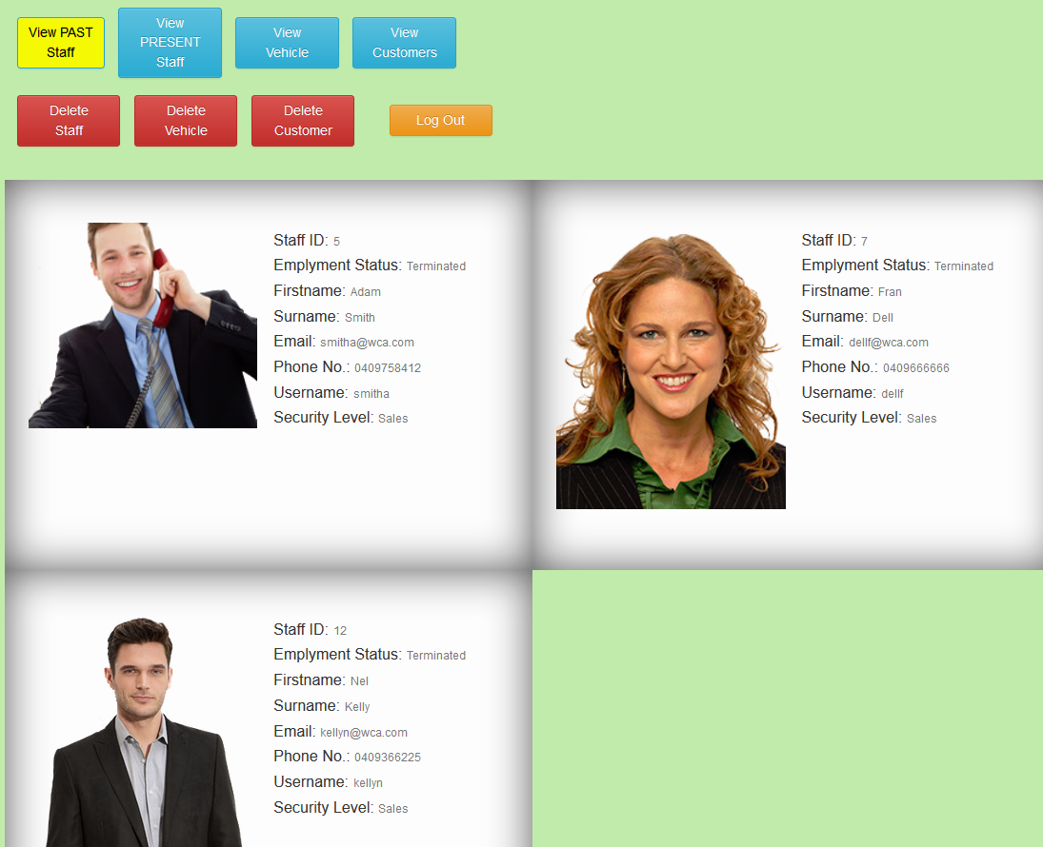

Figure 28: A view all staff members that have been “terminated” and no longer work at WCA.

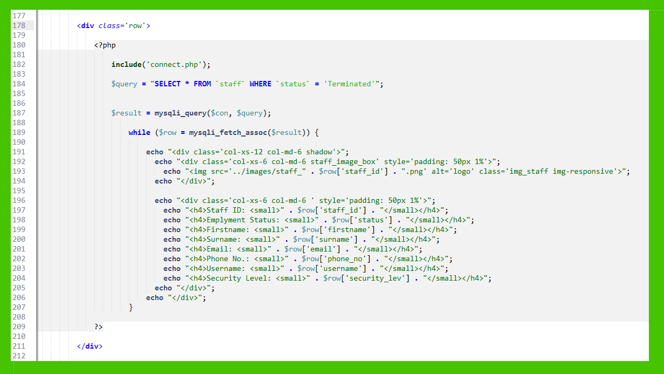

Figure 29: PHP script to view all staff members that have been “terminated” and no longer work at WCA.

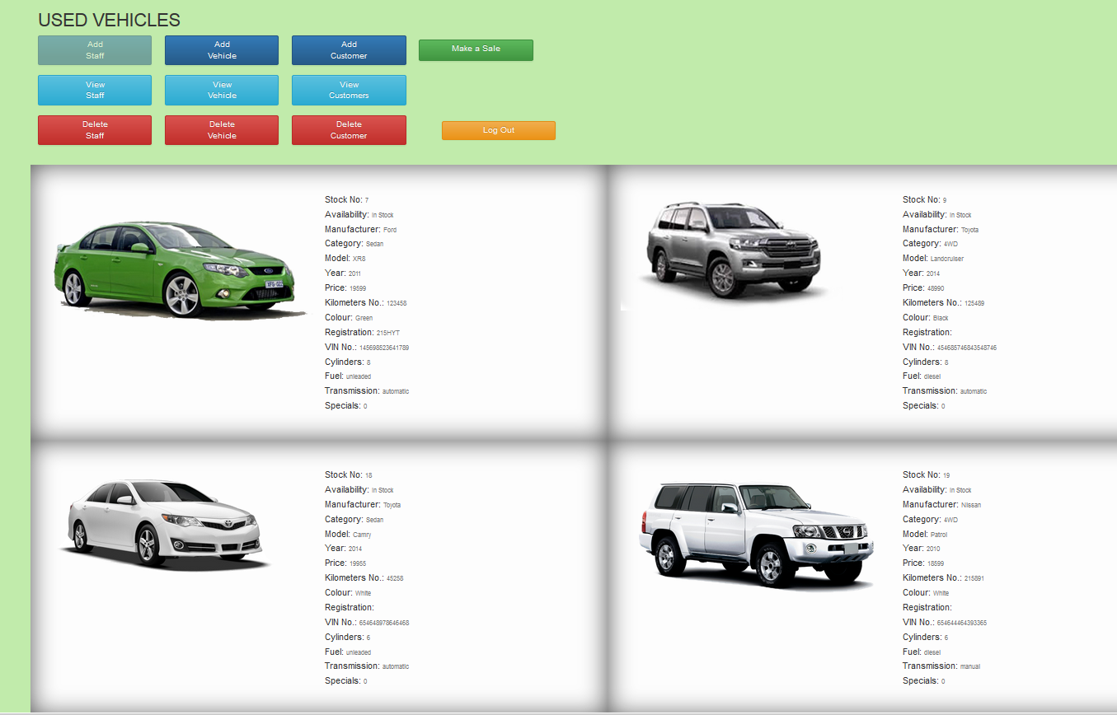

Figure 30: PHP script to view all current (or “In Stock”) vehicles, available for sale at WCA.

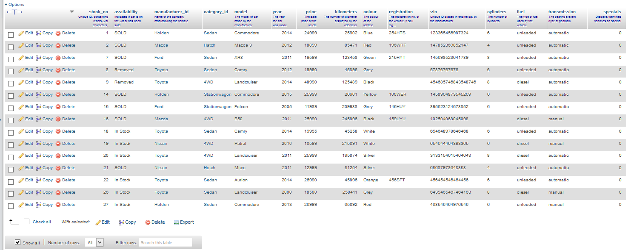

Figure 31: The current vehicle data stored in the “car” table in the database table.

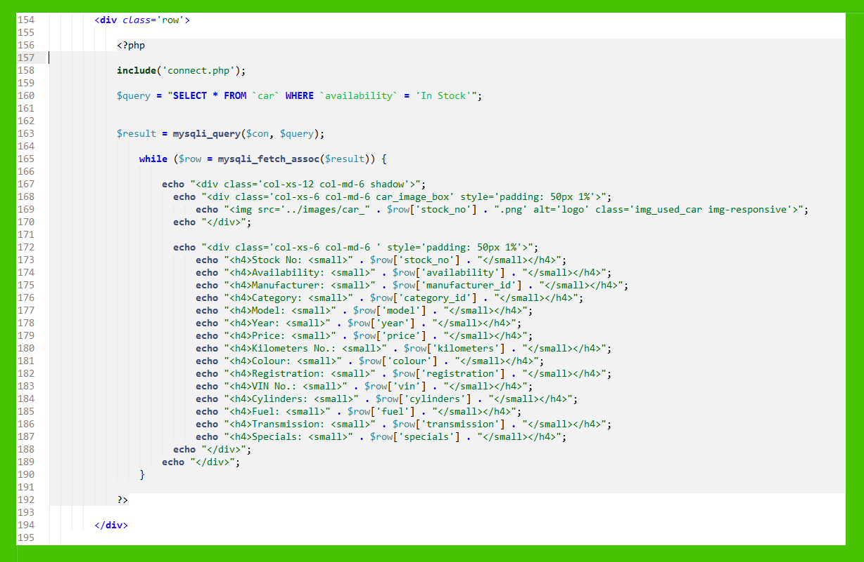

Figure 32: PHP script view all the vehicles available for sale (I.E. “In Stock”), in the database table.

* Salesperson (or “Sales”) User Interface (UI)
* 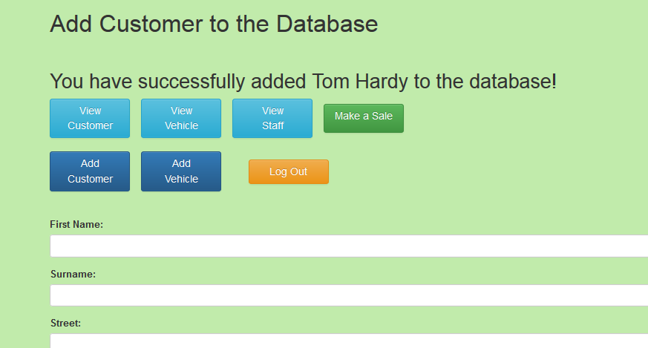

Figure 33: Feedback indicating the successful addition of a customer.



Figure 34: The success addition of a new customer, evidenced in the database table.

NOTE: See page 9 for the identical php code, required.

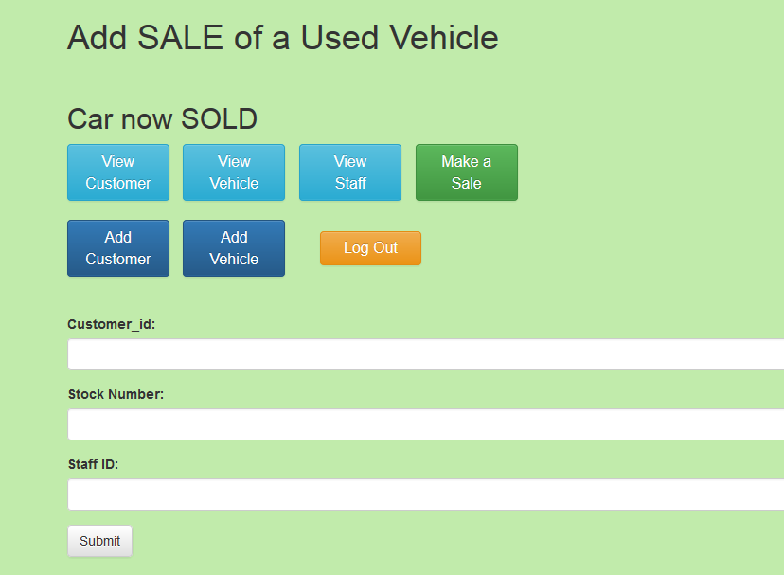

Figure 35: Feedback indicating the successful recording of the sale of a vehicle.

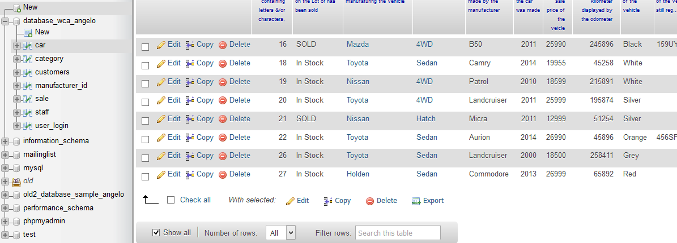

Figure 36: The successful recording of the sale of a vehicle, evidenced in the database table.

NOTE: See page 11 for the identical php code, required.

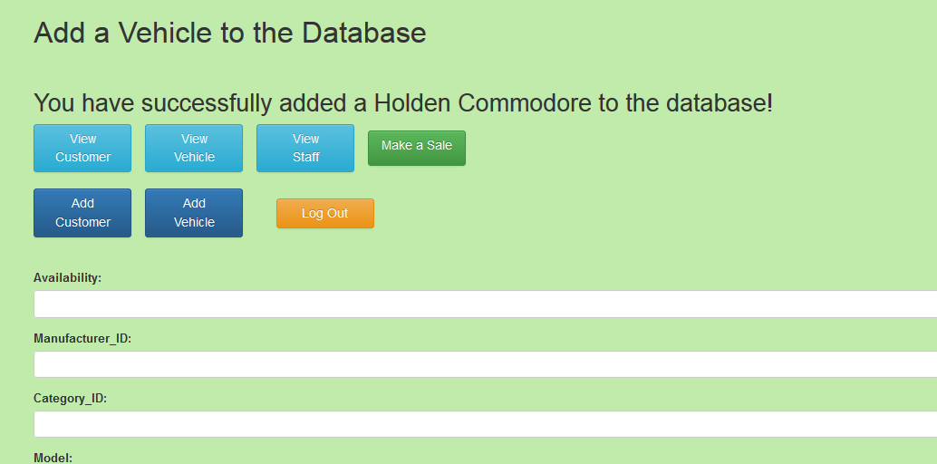

Figure 37: Feedback indicating the successful addition of a vehicle.

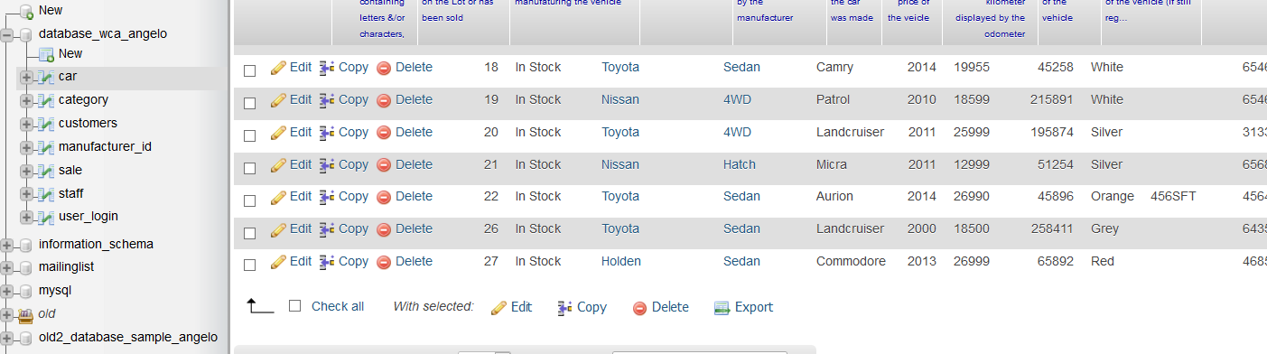

Figure 38: The success addition of a new vehicle, evidenced in the database table.

NOTE: See page 11 for the identical php code, required.

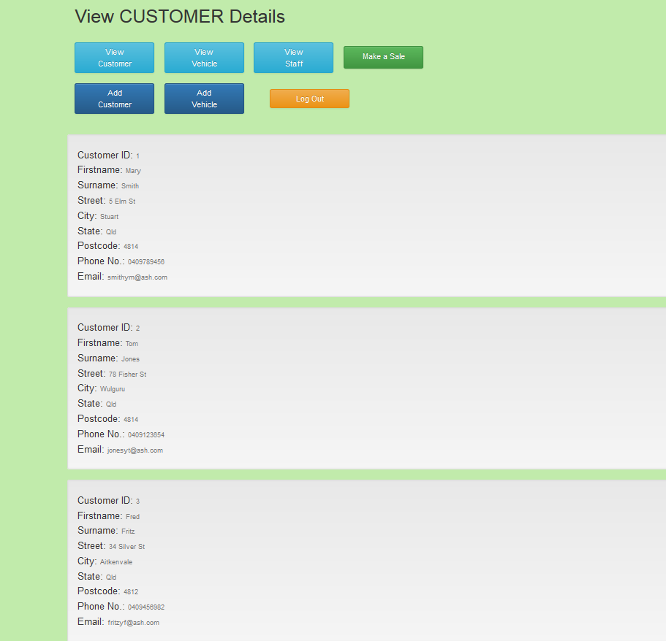

Figure 39: Feedback indicating the successful request to view the customer details.

NOTE: See page 19 for the identical php code, required.

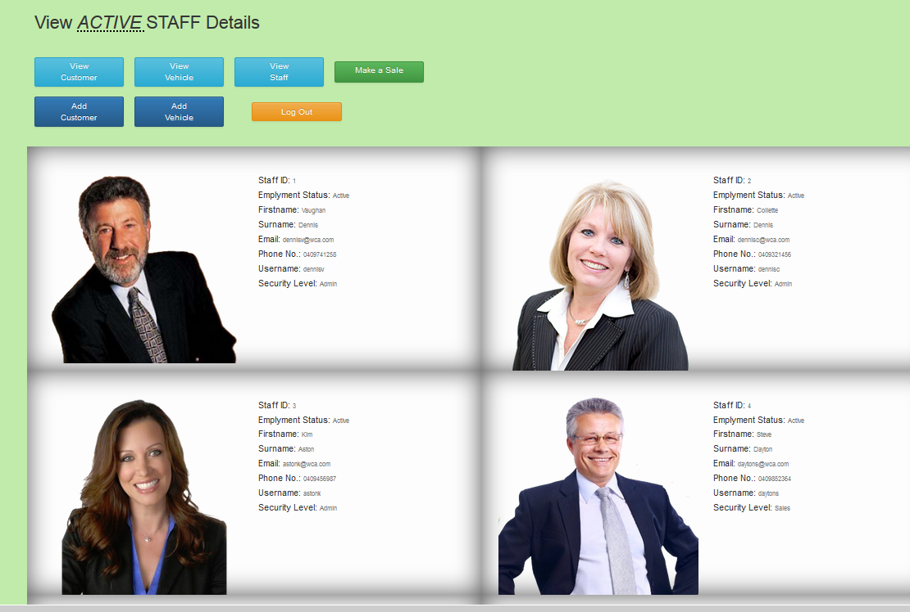

Figure 40: Feedback indicating the successful request to view the current (or “Active” staff members’ details.

NOTE: See page 20 for the identical php code, required.

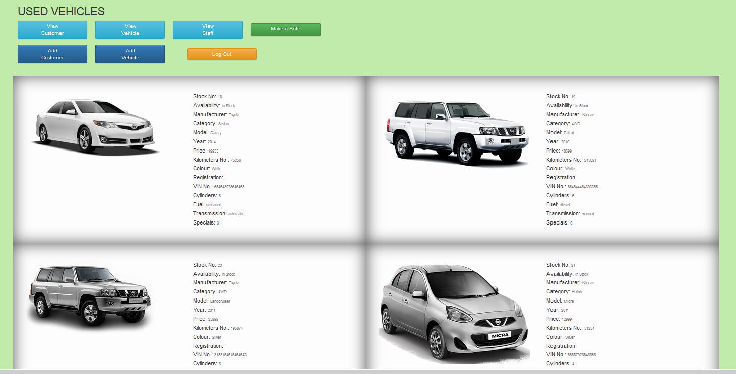

Figure 41: Feedback indicating the successful request to view the current (“In Stock”) vehicles, available for purchase.

NOTE: See page 23 for the identical php code, required.

* Outline the security and access control for your website, including a documented test of the security system to ensure functionality.

1. Login – the user must enter their username and password. The application then compares the entries against those stored in the database, and will only proceed if both exist together.

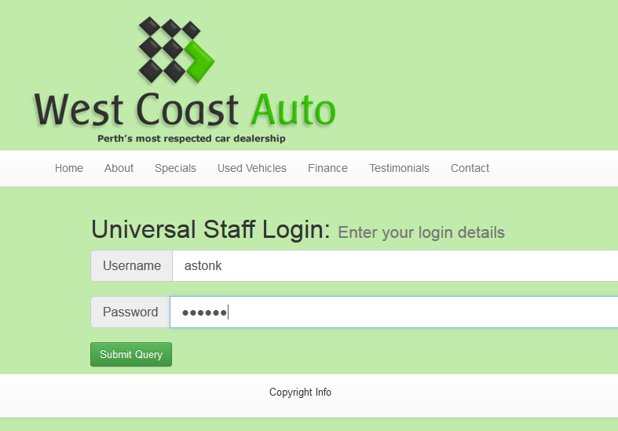

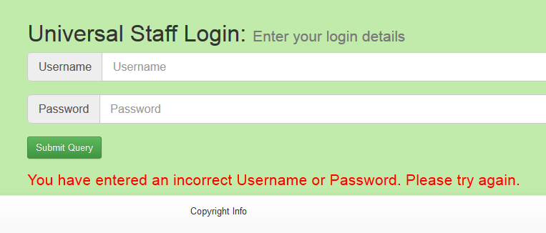

2. The username entered by the user passes through filters to remove characters (spaces, slashes and non-alpha-numeric characters) to prevent malicious code from being entered by the user.

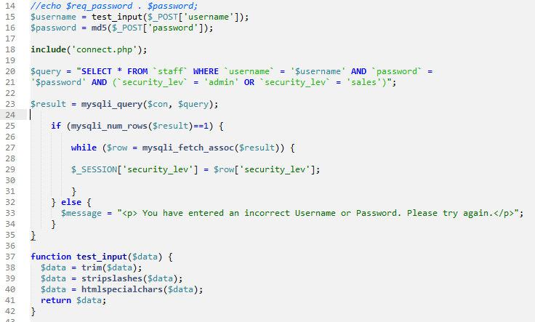



3. Security level access – At the same time as confirming the username and password, the script gets the security level corresponding to the username/password. It is worth noting that this is taken direct from inside the database rather than having it entered by the user at login. This security level is then used by the application to determine what is displayed on the screen, and thus, to what sections and features the user has access.

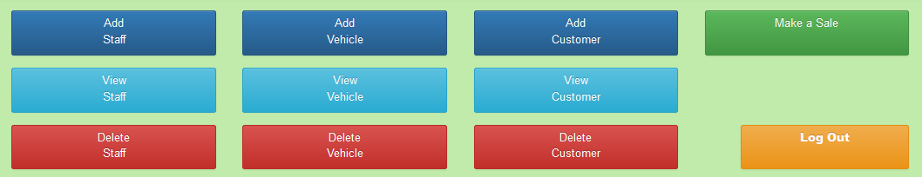 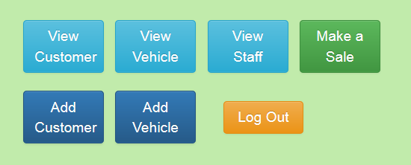

4. The passwords have been MD5 encrypted when entered into the database, thus ensuring that the actual password is never visible.



5. Whilst logging-in, the password they enter is “disguised” by a series of dots, so people in the vicinity cannot read the password on the screen.



6. All forms uses POST request (as opposed to GET) to ensure that the data entered in the form is not visible in the URL bar or cached to the browser history.

* Outline and recommend a plan for implementing this web application.

West Coast Auto has not stipulated a specific date for roll-out; and as such we will progress within a timeframe based on management and staff response to change.

1. The new system will be installed on the company network, but will not be made public.

2. Training programs will be implemented.

3. The website will be made public to gauge the public’s interaction with the site, but the site’s server-side facility will not be activated and as such, will not be useable. Statistical User Experience data will be gathered.

4. Based on staff and public user experience data, modifications may be made.

5. Data migration to occur.

6. Server-side database will be activated under supervision. All data handling will be monitored to ensure data integrity.

* Outline how to import old data into new database using phpmyadmin.

Since it has been decided to use phpMyAdmin as the ‘virtual’ server for the near future, we must first look at what formats phpMyAdmin will import data.

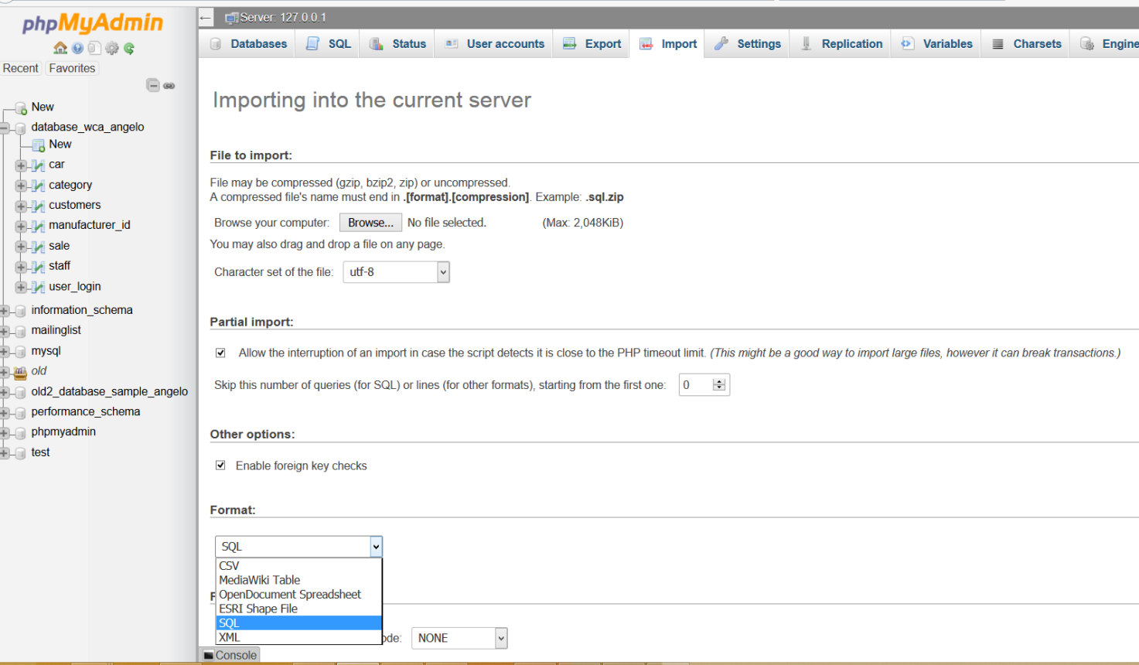

The image below shows the six formats which may be considered when it comes to packaging our existing data ready for import into the new environment. Of these, CSV and SQL are readily recognised and accessible. If the database exist in a MySQL Server the data can be easily exported using phpMyAdmin. To perform an export, simply go to the appropriate tab on the phpMyAdmin screen and complete the ‘form’ below. Then save the exported file onto a reliable device such as a flash drive or portable hard drive. This device will be used to transfer the data.

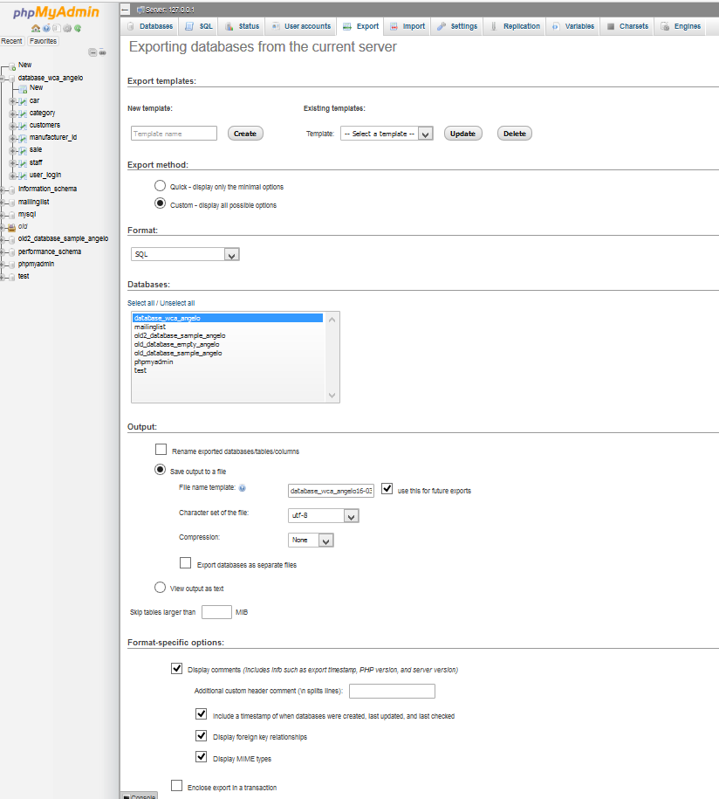

5. Select recommended options

4. Select a name for the exported file name

3. Select the database to export

1. Select “Custom” method

2. Select the format; SQL or CSV preferably

The import procedure is almost the reverse of the export procedure.

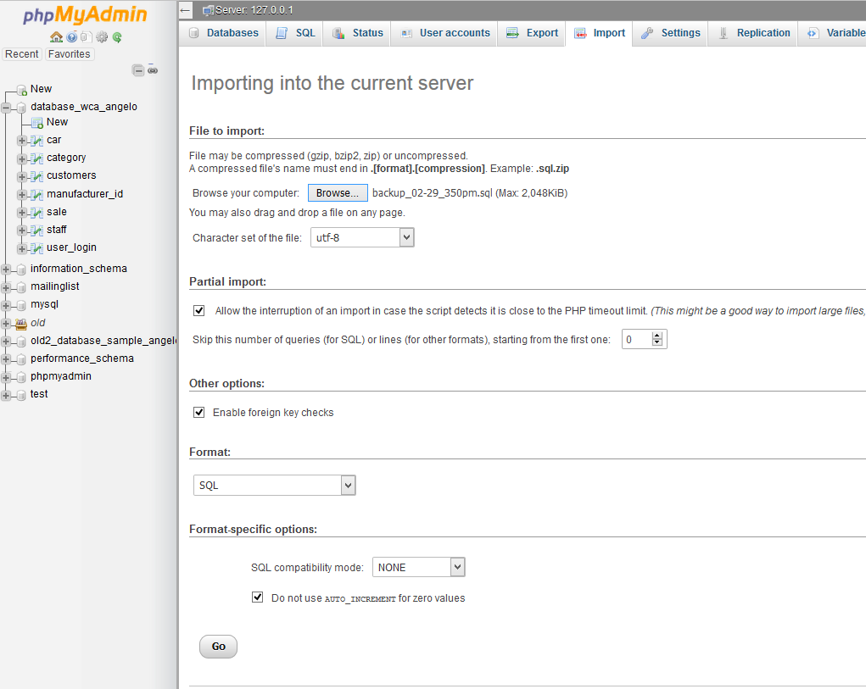

2. Select options

3. Select the format corresponding to the exported file format

1. Browse for your device and identify your exported database file

If not exporting from MySQL, attempt to export as a CSV file. Ensure that the formatting of the data contained in the CSV file is correct. The rest of the process is the same; just ensure that the import file format is set to CSV

* Identify and document user training requirements.

The training requirement, depend greatly on the experience and knowledge of the users and the management and maintenance requirements of the company. By this I mean to what extent the daily operations, and ongoing updates, modification and troubleshooting will be undertaken in-house by existing staff or out-sourced to website/database management professionals such as Online System Solutions.

West Coast Auto, is a relatively small company, in respect to staffing and business activity. As such the system required to manage their daily/yearly operation does not need to be large and complex. Following discussions with the management, it was decided that the company would manage the website and database, but reserve the option to call Online System Solutions if the need arises. As a result of this decision, and considering the factors raised earlier the following training program will be implemented.

1. Prior to the official roll-out, all relevant staff will participate in a one hour workshop in lieu of their regular staff meeting. While fully functional, the public will not have access and real data will not be used. During this session, the staff will be “walked-through” the entire site. All facets and features will be explored and discuss. Staff will run through set scenarios, from simple login to sales and more complex transactions.

2. A follow up session may be run, if staff would appreciate the hands-on, controlled session.

3. A series of short videos will be produced and made available to staff to view either at work or at home. These will be step-by-step instructions.

4. Relevant administrative staff will undertake a one half day training session on managing backup and restore procedures.

5. Administrative staff, responsible for the back-end management of the database, specifically working with SQL code, etc., will undertake a two week, intensive training course off-site.

6. Relevant administrative staff will also undertake a short training course on server management.

7. Once rolled-out, Online System Solutions will work with West Coast Auto for a period of up to two weeks, to monitor and support staff member’s interaction with the new system, during real-life situations.

* Outline the web application’s use of statefull/statelessness

The West Coast Auto web application incorporates both stateless and statefull elements. The application contains HTML pages, which are stateless in nature as described on pages 3 and 4 of this report – the page content is loaded in text form and remain only as long as the page is visible.

The application also contains PHP pages, which are stateful l in nature. The PHP code assigns variables that contain data/information. These variables, and especially global variable are able to retain the information longer and across pages in the applications.

In addition, the PHP coding is able to access data/information inside a database and assign this to variables and global variables..

One example of its statefullness, is the login facility. The user logs into the application; the code checks the validity of the login; and if successful, assigns the user’s security access level as a blobal variable. This variable is then used on every page to determine the content that this user is entitled to access.

Task 4 – Present your brief to the client (Teacher)

For this task you are required to sit down and present your website to your teacher:

* You will need to be prepared to sit down with your teacher and explain your website and gain client approval. You will need to discuss:
  + Web application functionality
  + Security, and
  + Recommended implementation plan.

Project Resources

Below are a number of resources needed to complete this project.

* [Requirements report](http://my.tafe.qld.gov.au/WBI/WBI_Information_Systems/WBI_ICADBS502A_TQC_A/IMS_2013v1/01_Design_db/project/resources/WCA_Requirements_Report.pdf) - this document describes the requirements of the project (PDF file 591Kb)
* Client logo - available in three formats: [west_coast_auto_logo](http://my.tafe.qld.gov.au/WBI/WBI_Information_Systems/WBI_ICADBS502A_TQC_A/IMS_2013v1/01_Design_db/project/resources/west_coast_auto_logo.png).png (PNG file 36Kb), [west_coast_auto_logo.jpg](http://my.tafe.qld.gov.au/WBI/WBI_Information_Systems/WBI_ICADBS502A_TQC_A/IMS_2013v1/01_Design_db/project/resources/west_coast_auto_logo.jpg) (JPG file 21Kb) and [west_coast_auto_logo.psd](http://my.tafe.qld.gov.au/WBI/WBI_Information_Systems/WBI_ICADBS502A_TQC_A/IMS_2013v1/01_Design_db/project/resources/west_coast_auto_logo.psd) (PSD file 226Kb)
* [Sitemap](http://my.tafe.qld.gov.au/WBI/WBI_Information_Systems/WBI_ICADBS502A_TQC_A/IMS_2013v1/01_Design_db/project/resources/West_Coast_Auto_Sitemap.pdf) - full page view of the sitemap from the requirements document (PDF file 100Kb)
* [Wireframe](http://my.tafe.qld.gov.au/WBI/WBI_Information_Systems/WBI_ICADBS502A_TQC_A/IMS_2013v1/01_Design_db/project/resources/west_coast_auto_wireframe.pdf) - full page view of the sitemap from the requirements document (PDF file 337Kb)

You will need to submit

The following should be included in your GitHub repository:

* Task 1 answers
* Website (Task 2)
* Database file (Task2)
* Written brief (Task 3)